Udkast til mapping scheme

Hvordan man kan mappe de forskellige sensordata til lyde.

På det generelle plan.

# 1. Note

## 1.a Enkelt tone

|  |  |  |  |  |  |  |  |  |  |  |  |
| --- | --- | --- | --- | --- | --- | --- | --- | --- | --- | --- | --- |
| **Oktav** | -2 | -1 | 0 | 1 | 2 | 3 | 4 | 5 | 6 | 7 | 8 |
| **Tone** | c | c# | d | d# | e | f | f# | g | g# | a | a# |

## 1.a.1 Velocitet

#### 1.a.1.a Lineær

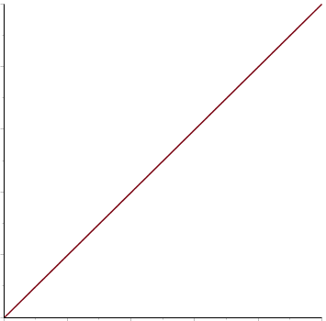

#### 1.a.1.c Logaritmisk

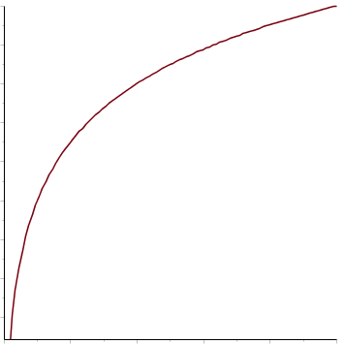

#### 1.a.1.b Eksponentiel

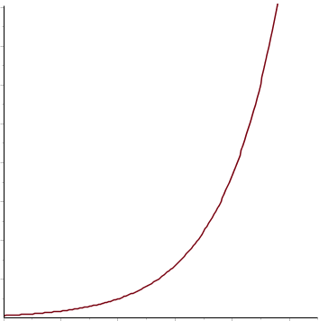

#### 1.a.1.c Fuld

#### 

## 1.b Kontinuerte toner

### 1.b.1 Skala

#### 1.b.1.a Kromatisk

Eksempelvis tonerne i intervallet”c1-c6”

#### 1.b.1.b Heltone

|  |  |  |
| --- | --- | --- |
| **Grundtone** | c | c# |

#### 1.b.1.c Pentaton

|  |  |  |  |  |  |  |  |  |  |  |  |  |
| --- | --- | --- | --- | --- | --- | --- | --- | --- | --- | --- | --- | --- |
| **Tonalitet** | Dur | | | | | | Mol | | | | | |
| **Grundtone** | c | c# | d | d# | e | f | | f# | g | g# | a | a# |

#### 1.b.1.d Diatonisk

|  |  |  |  |  |  |  |  |  |  |  |  |  |
| --- | --- | --- | --- | --- | --- | --- | --- | --- | --- | --- | --- | --- |
| **Tonalitet** | Dur | | | | | | Mol | | | | | |
| **Grundtone** | c | c# | d | d# | e | f | | f# | g | g# | a | a# |

#### 1.b.1.f Brugerdefineret (evt)

Bruger vælger en toneart samt toner fra kromatisk skala

### 1.b.2 Retning

|  |  |  |
| --- | --- | --- |
| **Retning** | Opadgående | Nedadgående |

# 2. Control Change

Der er i alt 128 styrbare CC-numre (kanaler), der kan antage værdi fra 0-128

### 2.a CC Nummer:

|  |  |
| --- | --- |
| **CC nummer** | 0-127 |

### 2.b CC styring:

#### 2.b.1 Absolute

CC får værdi ud fra nuværende sensormåling (uafhængig af tidligere måling)

|  |  |
| --- | --- |
| **Min Value** | 0-127 |
| **Max Value** | 0-127 |

#### 2.b.2 Relative (evt)

Nuværende CC-værdi in- eller dekrementeres med en given hastighed afhængigt af position ift. midterposition

|  |  |  |  |
| --- | --- | --- | --- |
| **Hastighed** | Slow | Medium | High |

# 3. Midi kanal

## 3.a Global

## 3.b Specifik kanal

|  |  |
| --- | --- |
| **Midi kanal** | 1-16 |